**Lab Practice Assignment 1**

Save each test script and screenshots of test result as per question number. Make a

zip folder of all the files. Upload the zip file to Moodle.

**Problem 1. (20%) Annotations**

Successfully run the example in session 5. JUnit 5 Annotations

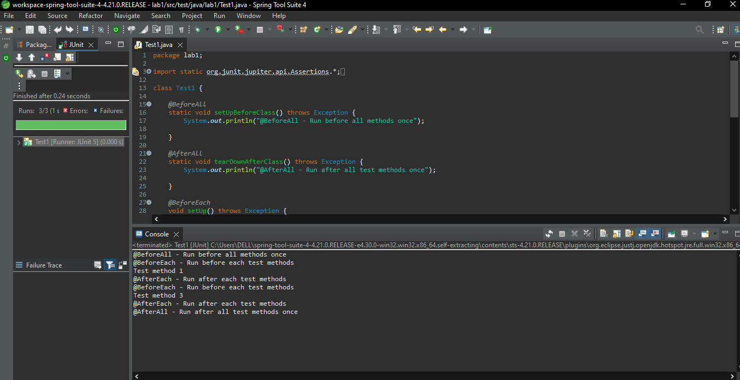

**Problem 2. (20%) Assertion**

Successfully run the example in part 1. AssertAll, AssertNotNull, and assertEquals.

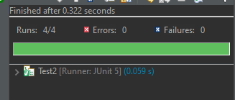

* AssertAll

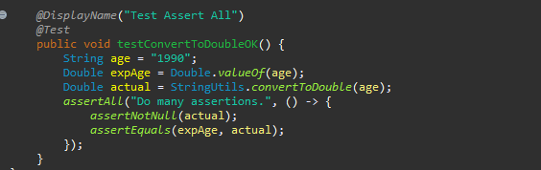

* AssertNotNull

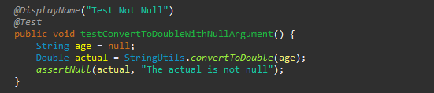

* AssertEquals

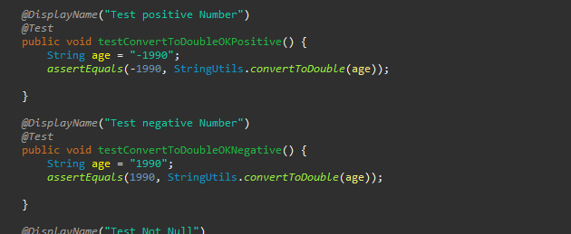

**Problem 3. (20%) Exception**

Successfully run the example in part 3. AssertThrows



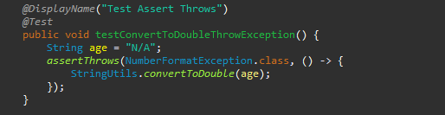

**Problem 4. (20%) ParameterizedTest 1**

Successfully run the example in part 6.1.a Simple Values

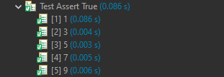

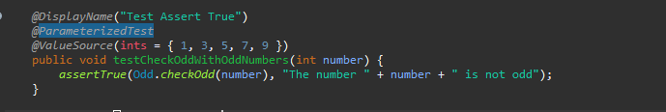

**Problem 5. (10%) ParameterizedTest 2**

Successfully run the example in 6.1.e CSV Files

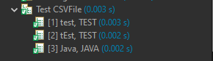

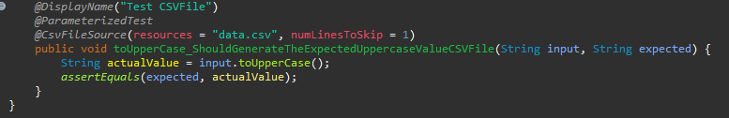

**Problem 6. (10%) ParameterizedTest 3**

Successfully run the example in 6.1.f Method

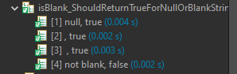

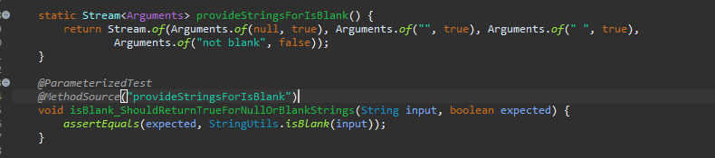

**~~The end~~**